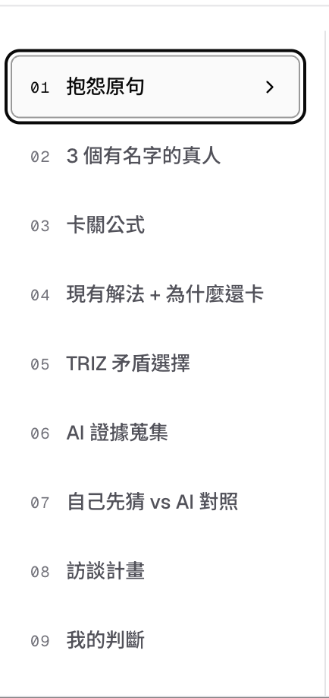

My new version :

- Card 1 Original complain
- Card 1 A; Using post this original complain to AI and check if this topic is too broad and let AI giving you three directions to narrow down
- Card 1-B Pick one of the direction and keep on asking more narrow down pain level those pain and come out those final more focus main point card 1 to Card 2 B is trying to define pain map to be more specific and narrow down the topic of pain
- Card 1- Card 3 finding more focus of pain: Examples, my English is not good, then post this pain into AI LLM, then LLM will try to find three major issue about having issue for being good in English, speaking , reading or listening, finding what is the actual issue
- Point card 4 卡關公式, finding what is the pain level, using what people can think and post this into AI and let AI find out more solutions and let them choose , if those solutions can really solve their pain , finding if that is correct right direction to find solutions to solve English capability issues.
- Follow by Cared 5 Triz, asking trade off questions, just put three trade off questions but need to pick a or b or what final pick and why , like I wish A and B, but if I need to pick I need to pick B , give reason, reason will become important key for finding real painmap
- Card 6, checking market by posing direct questions to AI , if three major evidence saying the same pain but really focus the card narrow down final focus pain not original pain, like phonics is a real issue for fixing speaking English well issue ,finding evident, this is a common pain
- Card 7 Finding three real people name and contact information phone , email, relationship and why choose pick answers by 5 potential answers
- Card 8 coming out the real interview card. Need to also define this is niche pain for certain grop of people or this is common pain for general group of people

